**Dental Clinic Services System**

Progress 2

Project Management Plan

By

**Kanokwan Maneerat 542115002**

**Worapun Wongkium 542115055**

Department of Software Engineering

College of Arts, Media, and Technology

Chiang Mai University

Project Adviser

______________________________

Miss Pattama Longani

**Project Management Plan**

**Revision Table**

|  |  |  |  |  |  |
| --- | --- | --- | --- | --- | --- |
| **Document Name** | **Detail** | **Status** | **Date** | **Viewable** | **Reviewer& Responsible** |
| DCSS – PMP - ver 0.1 | Add all document | Draft | 10/16/2014 | Adviser | Kanokwan & Worapun |
| DCSS – PMP - ver 0.2 | Edit all document | Draft | 10/21/2014 | Adviser | Kanokwan & Worapun |
| DCSS – PMP - ver 1.0 | Double check and correcting grammar | Release | 10/22/2014 | Adviser | Kanokwan & Worapun |

Table of Contents

Chapter One: Introduction 5

1. Introduction 5

1.1 Project Overview 5

1.1.1 Purpose 5

1.1.2 Scope 5

1.2 Document overview 5

1.3 Work product to be developed 6

1.3.1 Deliverables 6

1.4 Acronyms 7

1.4.1 Acronyms 7

1.4.2 Definition 7

Chapter Two: Infrastructure 10

2. Infrastructure 10

2.1 Software development life cycle 10

2.2 Development Tools 10

2.3 Hardware and Material Resources 11

Chapter Three: Management Procedures 12

3. Management Procedures 12

3.1 Project Team Structure 12

3.2 Monitoring and Controlling Mechanism 12

3.2.1 Project Meeting 12

Chapter Four: Quality Standard 13

4. Quality Standard 13

4.1 ISO29110 for Very Small Entity (VSE) 13

**4.1.1 Project Management (PM) process** 13

**4.1.2 Software Implementation (SI) process** 13

Chapter Five: Quality Planning 15

5. Quality Planning 15

5.1 Quality Factor 15

**Product operation factors** 15

**Product revision factors** 15

**Product transition factors** 15

Chapter Six: Estimated Responsibility, Schedule and Milestone 16

6. Estimated responsibility, schedule and milestone 16

6.1 Review/Responsibility 16

6.2 Testing 16

6.3 Estimated Effort and Cost 16

6.4 Schedule & Milestone 17

Chapter Seven: Version Control Strategy 21

7. Version control strategy 21

7.1 Filename format 21

7.2 Change Management 21

7.3 Project Repository 21

7.4 Software Configuration Item Table 22

Chapter Eight: Risk Management 23

8. Risk Management 23

8.1 Risk Management Process 23

8.2 Risk Identification and Solutions 24

# Chapter One: Introduction

## 1. Introduction

Dental clinic service system is created for reducing officers’ work and providing convenience to patients. This project will provide the dental clinic schedule for patients, officers, and dentists. Officer can manage the appointment schedule for dentist and patient. For example, officer can make an appointment for patient. Each of the users has limited functionalities allowed for each user type such as patients cannot change the appointments.

## 1.1 Project Overview

Dental clinic service system consists of a mobile application on iOS and a web application created for three types of users: patients, officers, and dentists. This system will manage patients’ appointments and dentists’ treatment schedule. It can scan QR code to identify patients, which solves the problem that patients often lose their appointment cards. It has a reminder function for patients about their appointment date, which helps reduce the number of phone calls the patients need to make to check their appointment date with the officers.

### 1.1.1 Purpose

This project management plan is a document for planning and scheduling activities, and evaluating the overall of the project to make sure the project follows the schedule and avoids the risk that may occur in the process. This document outlines the plan that will help complete the project as successfully as possible.

### 1.1.2 Scope

Dental clinic service system consists of a mobile application and a web application that are developed to serve small dental clinics. This application helps to manage the patients’ appointment date and send out reminders so that they can check their upcoming appointments on their mobile phone. For the patients who do not use a smart phone, the system will send a notification in SMS. It can generate the patients’ ID in the form of QR code and send it via email and the mobile application. This provides convenience to the patients as they do not need to bring their appointment card to the dental clinic. The officers can create, change, and delete the appointment. This system conforms to ISO 29110.

## 1.2 Document overview

The purpose of the Dental clinic service system plan is to guide team members and management while developing the Dental clinic service system’s mobile application and web application.

## 1.3 Work product to be developed

### 1.3.1 Deliverables

|  |  |  |  |  |
| --- | --- | --- | --- | --- |
| **No.** | **Deliverables/Release** | **Media** | **No. of copies** | **Date** |
| 1 | **Project Proposal**   * Dental clinic service system | Document | 3 | 03/25/2014 |
| 2 | **Progress Report 1**   * Software project management plan version 1.1 * Software requirement specification version 1.1 * Software design document version 1.1 * Test plan version 1.1 * Test record version 1.1 * Traceability record version 1.1 | Document  Document  Document  Document  Document  Document | 3  3  3  3  3  3 | 31/07/2014 |
| 3 | **Progress Report 2**   * Software project management plan version 1.0 * Software requirement specification version 1.0 * Software design document version 1.0 * Test plan version 1.0 * Test record version 1.0 * Traceability record version 1.0 | Document  Document  Document  Document  Document  Document | 3  3  3  3  3  3 | 10/22/2014 |
| 4 | **Final Progress Report**   * Software project management plan * Software requirement specification * Software design document * Test plan * Test record * Traceability record | Document  Document  Document  Document  Document  Document | 3  3  3  3  3  3 | 12/11/2014 |

## 

## 1.4 Acronyms

### 1.4.1 Acronyms

|  |  |
| --- | --- |
| **Acronyms** | **Stands for** |
| Registered User | Patient, Dentist, and Officer |
| Non-registered User | Visitor |
| PSR | Project Status Report |
| PM | Project Management |
| PMP | Project Management Plan |
| URS | User Requirement Specification |
| SRS | Software Requirement Specification |
| VSE | Very Small Entity |
| QR code | Quick Response Code |
| UC | Use Case |
| AD | Activity Diagram |
| UI | User Interface |
| UTC | Unit Test Case |
| STC | System Test Case |
| CD | Class Diagram |
| SD | Sequence Diagram |

### 1.4.2 Definition

Acceptance test Test activities for sample checks to verify a system (or product, solution) has the right quality for deployment or usage. Often acceptance test is done by customer [IEEE90]

Feature Transformation of input parameters to output parameters based on specified algorithm. It describes the functionality of the product. Used for requirements analysis, design, coding, testing or maintenance. [IEEE90]

IEEE Institute for electrical and electronic engineers. Biggest global interest group for engineers of different branches and computer scientist [IEEE90]

Plan A documented series of task requires meeting an objective, typically including the associated schedule, budget, resources, organizational, description and work breakdown structure [IEEE90]

Project Management The application of knowledge, skills, tools, and techniques to project activities in order to meet or exceed stakeholder needs and expectations from a project [IEEE90]

Project Plan A formal, approved document used to guide both project execution and project control. The primary uses of the project plan are to document planning assumptions and the decision, to facilitate communication among stakeholders, and to document approved scope, scope, cost, and schedule baseline. [IEEE90]

Risk An uncertain event or condition that, if it occurs, has a positive or negative effect on a project’s objectives. It is a function of the probability of occurrence of a given threat’s occurrence. [IEEE90]

Risk Management The systematic application of management policies, procedures and practices to the tasks of identifying, analyzing, evaluating, treating and monitoring risk. [IEEE90]

Traceability The ability to trace the history, application or location of an item or activities, by means of recorded identification. The establishment and maintenance of relationships between such items. Horizontal traceability describes the relationship between work products of the same type (e.g. customer requirement). Vertical traceability describes the relationship between work products, which build upon each other or derived from each other (e.g. from customer requirements to qualification test cases). Bidirectional traceability allows to directly following relationships in both directions. [IEEE90]

Unit test A test of individual programs or modules in order to remove design or programming errors. [IEEE90]

Validation Confirmation by examination and provision of objective evidence that the particular requirements for a specific intended use a fulfilled (“doing the right thing”).Part of quality control.

Verification Confirmation at the end of the process by examination and provision of objective evidence that specified requirements to the process has been fulfilled (“doing things right”). Part of quality control. [IEEE90]

QR code two-dimensional barcodes that can be read by many cell phones and smartphones. The codes, which are small squares with black and white patterns, appear in a variety of places, such as magazine and newspaper ads. A QR code is used to encode some sort of information, such as text or a URL.

# Chapter Two: Infrastructure

## 2. Infrastructure

## 2.1 Software development life cycle

Iterative and Incremental development is a process that separates the large feature into small chucks. Planning, requirement analysis, design, development, testing, and evaluation are repeated in cycle for each chunk. In each iteration, addition features are designed, developed, tested, and integrated with the pre-developed features until a fully functional software system is ready to be deployed to customers.

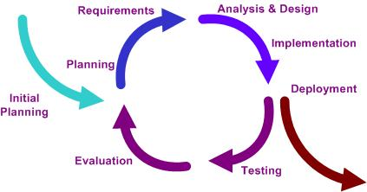

Figure 1: Iterative and Incremental Development model

Dental clinic services system uses the iterative and incremental development model because this process can reduce the risks that may occur in the process and make project management easier. In each cycle, a small set of features are developed and documented to fulfill the requirements defined for each progress.

## 2.2 Development Tools

* **CodeIgniter version 2.1.4**

CodeIgniter is an open source web application development framework. CodeIgniter allows user to use both HTML and PHP language and also support fully MVC pattern.

* **Xcode version 5.0**

Xcode is an IDE for developing software for iOS and OSX, contains iOS simulator for developing iPhone and iPad application.

* **PhoneGap version 2.9.1**

PhoneGap is a free open source that allow user to create hybrid mobile application by using HTML5.

* **MySQL server**

PhpMyAdmin 2.10.3 is used for database because it supports a wide range in MySQL, easy to use and it is free tools.

* **Adobe Dreamweaver CC**

Dreamweaver is the development tools that use to create HTML and PHP webpage from Adobe.

## 2.3 Hardware and Material Resources

* **Computer**
* **Dell Inspiron N4110**

**Processor:** Intel(R) Core(TM) i3-2310M CPU@ 2.10GHz, 2.10 GHz

**Memory:** 6.00 GB

**Operating system:** Window 7 Ultimate

* **Sony VAIO SVE14118FHB**

**Processor:** Intel(R) Core(TM) i7-3612QM CPU@ 2.10GHz, 2.10 GHz

**Memory:** 8.00 GB **Operating system:** Windows 7 Home Premium

* **MacBook Pro**

**Processor:** 2.5 GHz Intel Core i5

**Memory:** 4 GB 1600 MHz DDR38.00 GB

**Operating system:** W OS X 10.9.2 (13C1021)

* **iPhone**
* **iPhone 5s**

**Processor:** Dual core, 1300 MHz

**Memory:** 32 GB internal storage, 1 GB RAM DDR3

**Operating** System: iOS7

# Chapter Three: Management Procedures

## 3. Management Procedures

## 3.1 Project Team Structure

|  |  |  |
| --- | --- | --- |
| **Responsibility** | **Owner** | **Reviewer** |
| Project proposal | Kanokwan & Worapun | Kanokwan & Worapun |
| Project plan and Quality plan | Kanokwan & Worapun | Kanokwan & Worapun |
| Requirement specification | Kanokwan & Worapun | Kanokwan & Worapun |
| Design document | Kanokwan & Worapun | Kanokwan & Worapun |
| Test Plan | Kanokwan & Worapun | Kanokwan & Worapun |
| Tractability record | Kanokwan & Worapun | Kanokwan & Worapun |
| Testing record | Kanokwan & Worapun | Kanokwan & Worapun |

## 3.2 Monitoring and Controlling Mechanism

### 3.2.1 Project Meeting

|  |  |
| --- | --- |
| **Participants** | **Roles** |
| Miss Kanokwan Maneerat | Development team member |
| Miss Worapun Wongkium | Development team member |
| Miss Pattama Longani | Project Advisor |

# Chapter Four: Quality Standard

## 4. Quality Standard

**4.1 ISO29110 for Very Small Entity (VSE)**

The ISO29110 contain 2 processes are Project management and Software implementation.

**4.1.1 Project Management (PM) process**

* **PM purpose**

The purpose of the Project Management process is to establish and carry out in a systematic way the tasks of the software implementation project, which allows complying with the project’s objectives in the expected quality, time and costs.

* **PM objectives** 
  + ***PM.O1:***The Project Plan for the execution of the project is developed according to the Statement of Work and validated with the Customer. The tasks and resources necessary to complete the work are sized and estimated
  + ***PM.O2:***Progress of the project is monitored against the Project Plan and recorded in the Progress Status Record. Corrections to remediate problems and deviations from the plan are taken when project targets are not achieved. . Appropriate treatment is taken to correct or avoid the impact of risk. Closure of the project is performed to get the Customer acceptance documented in the Acceptance Record.
  + ***PM.O3:*** The Change Requests are addressed through their reception and analysis. Changes to software requirements are evaluated for cost, schedule and technical impact.
  + ***PM.O4:*** Review meetings with the Work Team and the Customer are held. Agreements are registered and tracked.
  + ***PM.O5:*** Risks are identified as they develop and during the conduct of the project.
  + ***PM.O6:*** A software Version Control Strategy is developed. Items of Software Configuration are identified, defined and baselined. Modifications and releases of the items are controlled and made available to the Customer and Work Team including the storage, handling and delivery of the items.
  + ***PM.O7:*** Software Quality Assurance is performed to provide assurance that work products and processes comply with the Project Plan and Requirements Specification.

* **PM Activities**

The Project Management Process has the following activities:

- PM.1 Project Planning

- PM.2 Project Plan Execution

- PM.3 Project Assessment and Control

- PM.4 Project Closure

**4.1.2 Software Implementation (SI) process**

* **SI purpose**

The purpose of the Software Implementation process is the systematic performance of the analysis, design, construction, integration and tests activities for new or modified software products according to the specified requirements.

* **SI objectives**
* ***SI.O1:*** Tasks of the activities are performed through the accomplishment of the current Project Plan.
* ***SI.O2:*** Software requirements are defined, analyzed for correctness and testability, approved by the Customer, baselined and communicated.
* ***SI.O3:*** Software architectural and detailed design is developed and baselined. It describes the software items and internal and external interfaces of them. Consistency and traceability to software requirements are established.
* ***SI.O4:*** Software components defined by the design are produced. Unit test are defined and performed to verify the consistency with requirements and the design. Traceability to the requirements and design are established.
* ***SI.O5:*** Software is produced performing integration of software components and verified using Test Cases and Test Procedures. Results are recorded at the Test Report. Defects are corrected and consistency and traceability to Software Design are established.
* ***SI.O6:*** A Software Configuration that meets the Requirements Specification as agreed to with the Customer, which includes user, operation and maintenance documentations is integrated, baselined and stored at the Project Repository. Needs for changes to the Software Configuration are detected and related Change Requests are initiated.
* ***SI.O7:*** Verification and Validation tasks of all required work products are performed using the defined criteria to achieve consistency among output and input products in each activity. Defects are identified, and corrected; records are stored in the *Verification/Validation Results.*

* **SI activities**

The Software Implementation Process has the following activities:

- SI.1 Software Implementation Initiation

- SI.2 Software Requirements Analysis

- SI.3 Software Architectural and Detailed Design

- SI.4 Software Construction

- SI.5 Software Integration and Tests

- SI.6 Product Delivery

# Chapter Five: Quality Planning

## 5. Quality Planning

**5.1 Quality Factor**

**Product operation factors**

|  |  |
| --- | --- |
| * Correctness | The software product should be able to provide 100% correctness of data from user request. |
| * Reliability | The software product should be able to handle more than 90% of activity with less than 10% of software failure. |
| * Integrity | The software product should be able to identify users which are patient, officer, and dentist. |
| * Usability | User who use software product at first time should be able to use all features within 30 minutes. |

**Product revision factors**

|  |  |
| --- | --- |
| * Maintainability | The software product should have 15-20% of comment comparing with the whole LOC. |
| * Testability | The software product should be able to test 100% of it defined routine and functionality. |

**Product transition factors**

|  |  |
| --- | --- |
| * Reusability | More than 30% part of finished software product should be able to reuse in future development. |

# Chapter Six: Estimated Responsibility, Schedule and Milestone

## 6. Estimated responsibility, schedule and milestone

## 6.1 Review/Responsibility

|  |  |  |  |  |
| --- | --- | --- | --- | --- |
| **Stage Exit Review** | | | | |
| **No.** | **Stage** | **Review Item** | **Owner** | **Reviewer** |
| 1 | Progress #2 | Software project management plan | Kanokwan & Worapun | Kanokwan & Worapun |
| 2 | Progress #2 | Software requirement specification | Kanokwan & Worapun | Kanokwan & Worapun |
| 3 | Progress #2 | Software design document | Kanokwan & Worapun | Kanokwan & Worapun |
| 4 | Progress #2 | Test plan | Kanokwan & Worapun | Kanokwan & Worapun |
| 5 | Progress #2 | Test record | Kanokwan & Worapun | Kanokwan & Worapun |
| 6 | Progress #2 | Traceability record | Kanokwan & Worapun | Kanokwan & Worapun |
| 7 | Progress #2 | Project Status Report | Kanokwan & Worapun | Kanokwan & Worapun |
| 8 | Progress #2 | Executive Summary | Kanokwan & Worapun | Kanokwan & Worapun |

## 6.2 Testing

|  |  |  |
| --- | --- | --- |
| **Test Process** | | |
| **No.** | **Test** | **Participation** |
| 1 | Unit testing | Kanokwan & Worapun |
| 2 | Integration testing | Kanokwan & Worapun |
| 3 | Acceptance Testing | Kanokwan & Worapun |

## 6.3 Estimated Effort and Cost

Estimate effort and cost of Dental clinic service system have:

* Rent the web server
* Register for Apple developer
* Webcam QR code scanner

## 6.4 Schedule & Milestone

|  |  |  |
| --- | --- | --- |
| **Milestone** | **Features** | **Submission Date** |
| **Progress 1** | Feature 1: Schedule management  Feature 2: User registration and authentication  Feature 3: Appointment management | 31st July, 2014 |
| **Progress2** | Feature 4: Patient identification using QR code  Feature 5: Dental care consulting and following up  Feature 6: A dental clinic information and promotion  Feature 7: Cost estimation of dental treatments | 22rd October, 2014 |
| **Final Progress** | Fully functioning system  Complete set of documents | 11th December, 2014 |

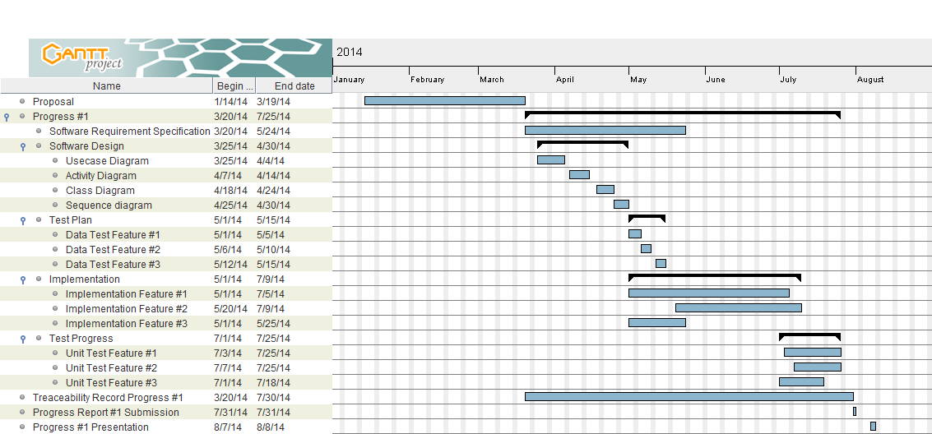

Figure 2: Milestone of Proposal and Progress 1

The proposal stage starts around January and continues until the mid-March.

Progress 1 starts around mid-March until July.

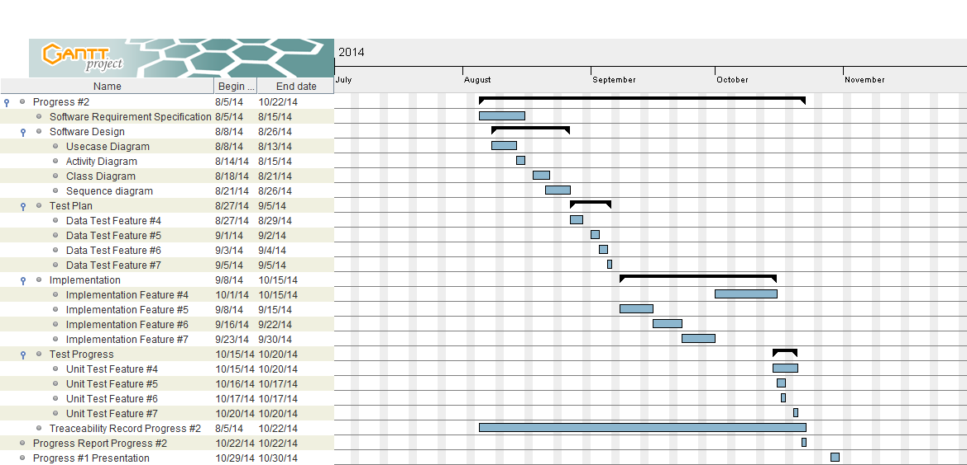

Figure 3: Milestone of Progress 2

Progress 2 starts around August and continues until mid-September.

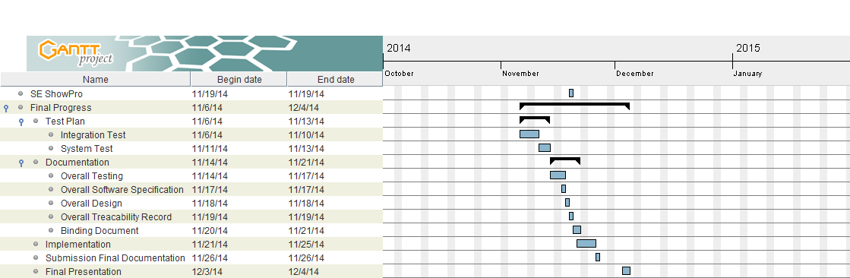

Figure 4: Milestone of SE ShowPro and Final Progress

SE ShowPro is 19th November 2014.

Final progress is from after ShowPro day continues until December.

# Chapter Seven: Version Control Strategy

## 7. Version control strategy

## 7.1 Filename format

The filename format which use for all project document is

* [Project name]-[Document name]-[Version].file type

## 7.2 Change Management

Change management are management all of changes in the project during development process. All of change request will be recorded to the change request document.

* The strategy for manage the changes following these steps :
* Analyze for changing
* Make a conclusion from change request
* Approve the change request by project advisor
* Change the project follows by approve change request

## 7.3 Project Repository

GitHub is a [web-based hosting service](http://en.wikipedia.org/wiki/Shared_web_hosting_service) for software development projects that use the [Git](http://en.wikipedia.org/wiki/Git_%28software%29) [revision control](http://en.wikipedia.org/wiki/Revision_control) system. The site provides [social networking](http://en.wikipedia.org/wiki/Social_networking) functionality such as feeds, followers, wikis and the [social network graph](http://en.wikipedia.org/wiki/Social_network_graph) to display how developers work on their versions of a repository.

Github is a tool that can help to manage the version of document and software. We can share file or update version of file in the time with team member. This tool is very easy to use. Github can create own folder in Github folder and share this folder to anyone in team meber and advisor.

## 7.4 Software Configuration Item Table

|  |  |  |  |  |  |  |
| --- | --- | --- | --- | --- | --- | --- |
| **No.** | **Item** | **File name** | **File Type** | **Owner** | **Path** | **Baseline version** |
| 1 | Project proposal | DCSS – Proposal – v 1.2 | .docx | Kanokwan&Worapun | C:\Users\SONY\Documents\GitHub\DentalClinicServicesSystem\progress2 | 1.2 |
| 2 | Project management plan | DCSS – PMP – v 1.0 | .docx | Kanokwan&Worapun | C:\Users\SONY\Documents\GitHub\DentalClinicServicesSystem\progress2 | 1.0 |
| 3 | Software requirement Specification | DCSS – SRS – v 1.0 | .docx | Kanokwan&Worapun | C:\Users\SONY\Documents\GitHub\DentalClinicServicesSystem\progress2 | 1.0 |
| 4 | Software design document | DCSS – SDD – v 1.0 | .docx | Kanokwan&Worapun | C:\Users\SONY\Documents\GitHub\DentalClinicServicesSystem\progress2 | 1.0 |
| 5 | Test plan | DCSS – Test Plan – v 1.0 | .docx | Kanokwan&Worapun | C:\Users\SONY\Documents\GitHub\DentalClinicServicesSystem\progress2 | 1.0 |
| 6 | Test Record | DCSS – Test Record – v 1.0 | .docx | Kanokwan&Worapun | C:\Users\SONY\Documents\GitHub\DentalClinicServicesSystem\progress2 | 1.0 |
| 7 | Traceability record | DCSS – Traceability Record – v 1.0 | .docx | Kanokwan&Worapun | C:\Users\SONY\Documents\GitHub\DentalClinicServicesSystem\progress2 | 1.0 |

# Chapter Eight: Risk Management

## 8. Risk Management

Risk management is concerned with identifying risks and plans to minimize their effect on the project such as scope or complexity.

* Define the Risk Management Process
* Identify Risks
* Perform a Quantitative and Qualitative Risk Assessment
* Create a Risk Response Plan
* Monitor Risk

All identified risk are documented in the Risk Management Process by the Project Team. In the Risk Management Process defines the possible risk and solution of them, and who responsible for.

## 8.1 Risk Management Process

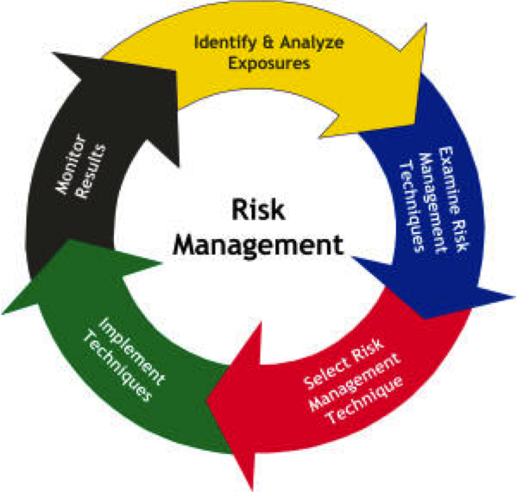 Figure 5: Risk Management Process Model

As shown in Figure 5, the risk management starts with identifying and analyzing risks. Then, potential ways to manage risks are examined and appropriate risk management techniques are selected. Those selected techniques are implemented. Finally, the results are monitored.

## 8.2 Risk Identification and Solutions

|  |  |  |
| --- | --- | --- |
| **Risk** | **Solution** | **Priority** |
| **Human Risks** | | |
| Team members are lack of skill and knowledge | Learn from text book and website. Find more resource and example from Google. | High |
| Bad communication between team members | Have more meeting and exchange the information between each other. | Medium |
| **Technology Risks** | | |
| Different platform and operating system | Find the technologies that support many different platform and operating system. | Medium |
| File crash | Use repository and always back up all the files both in computer and repository. | High |
| **Process Risk** | | |
| Date of submitting change | Try to finish the works on time. | Medium |